**CHAPTER 1**

**INTRODUCTION**

Resin Transfer Moulding (RTM) is a manufacturing process that involves the injection of a liquid thermosetting resin into a mold cavity containing a preform made of reinforcing fibers. The process is used to produce high-strength composite parts with excellent mechanical properties, such as high strength-to-weight ratio, stiffness, and durability. RTM was first developed in the 1960s as an alternative to traditional manufacturing processes, such as hand lay-up and compression molding, which were labor-intensive and produced parts with inconsistent quality[1]. RTM offered several advantages over these processes, including the ability to produce complex shapes with tight tolerances and smooth surfaces, high production rate, and low cost.

The process begins with the creation of a preform made of reinforcing fibers, such as carbon fibers, glass fibers, or aramid fibers. The preform is placed in a mold cavity, and the mold is closed to create a sealed space. The liquid thermosetting resin is then injected into the mold cavity under high pressure, using specialized injection equipment[2]. The resin fills the cavity and impregnates the fibers, forming a composite part. The mold is heated to cure the resin, which causes it to harden and bond with the fibers, forming a solid composite part.

The RTM process offers several benefits over traditional manufacturing processes. For example, it allows to produce complex shapes with tight tolerances and smooth surfaces, which are difficult to achieve with other methods. It also offers high production rates and low cost, making it an attractive option for high-volume production. Additionally, the process allows for the use of a wide range of materials, including different types of fibers, resins, and additives, which can be tailored to achieve specific properties. However, the RTM process requires specialized equipment and expertise, which can be a barrier to entry for some manufacturers. The process also requires careful control of temperature and pressure to ensure uniform distribution of the resin throughout the preform and to avoid any defects in the final product. RTM is a highly effective manufacturing process for producing high-strength composite parts with excellent mechanical properties.

It has revolutionized the production of composite parts, offering several advantages over traditional manufacturing processes. The process requires specialized equipment and expertise, but it can be an attractive option for high-volume production. Another benefit of RTM is the ability to tailor the properties of the composite by selecting different fiber types, orientations, and resin formulations. This versatility enables engineers to optimize the material's strength, stiffness, and other mechanical characteristics to meet specific design requirements.

The RTM process also offers environmental advantages compared to traditional manufacturing techniques. It produces less waste and emissions, and the use of reusable molds contributes to overall sustainability. While RTM offers numerous benefits, it is a complex and technically demanding process that requires expertise in mold design, resin formulation, and process control. However, advancements in automation and simulation tools have made RTM more accessible and cost-effective in recent years. Overall, Resin Transfer Molding is a versatile and efficient manufacturing method for producing high-performance composite parts with excellent structural properties, making it a preferred choice for various industries seeking lightweight and durable solutions.

Regarding manufacture, composites are special because the material is often created not before, but during the manufacture of a part. This is the case in the resin transfer molding (RTM) process, in which fibers are first placed in a closed mold, followed by injection of a thermosetting plastic resin into the mold, making a continuous matrix around the fibers. RTM was first deployed commercially in the 1970s and is now well developed. It is typically well-suited to production volumes up to 10,000 units/year, offering considerable form freedom and good potential for functional integration. As an example, the bodywork of the famous Lotus Esprit consisted of just two parts: the upper half and the lower half (made with RTM since 1987). The more recent BMW i3 also uses a variant of this process and represents a breakthrough in high-volume mass production of carbon fiber composites.

**1.1. BACKGROUND OF RTM**

Resin transfer moulding (RTM) is a composite manufacturing process that involves injecting liquid resin into a mold cavity containing a reinforcement material, such as carbon fiber or fiberglass, to create a composite part. Developed in the 1960s, RTM offers several advantages over other composite manufacturing methods, including improved part consistency, reduced cycle time, and the ability to produce complex geometries and large parts. RTM is widely used in industries such as aerospace, automotive, and marine to produce high-quality composite parts with a controlled resin content. This process offers several advantages over other composite manufacturing methods, such as improved part consistency, reduced cycle time, and the ability to produce complex geometries and large parts. Today, RTM is widely used in a range of industries, including aerospace, automotive, and marine, to produce high-quality composite parts with a high fiber volume fraction and a controlled resin content.

Resin Transfer Moulding (RTM) has its roots in the development of composite materials, which gained significant attention in the mid-20th century. The aerospace industry sought lightweight and high-strength materials for aircraft structures. This led to the exploration of various manufacturing processes, including RTM, to produce composite components. RTM evolved from the concept of liquid composite molding (LCM), which involves injecting liquid resin into a mold cavity containing reinforcing fibers. The first patent for a resin transfer molding process was filed in 1947 by Dr. B.F. Goodrich, who recognized the potential for manufacturing composite parts with improved quality and efficiency.

Initially, RTM faced challenges related to the flow of resin through the preform and the prevention of voids and defects. Over time, advancements in mold design, tooling materials, resin formulations, and process control techniques helped overcome these challenges and establish RTM as a reliable manufacturing method. In the 1960s and 1970s, RTM gained further attention in the automotive industry. Automakers sought lightweight alternatives to traditional metal components to improve fuel efficiency. RTM offered the possibility of producing complex shapes with precise control over fiber placement, resulting in components with excellent strength-to-weight ratios. As composite materials and manufacturing techniques continued to evolve, RTM became increasingly popular in other industries as well. It found applications in marine, wind energy, sporting goods, and other sectors where lightweight, strong, and corrosion-resistant materials were in demand.

In recent years, advancements in material science, computer-aided design, simulation tools, and automation have further improved the RTM process. Researchers and engineers continue to explore new variations of RTM, such as vacuum-assisted resin transfer molding (VARTM) and high-pressure resin transfer molding (HP-RTM), to enhance the process's capabilities and broaden its range of applications. Today, RTM is a well-established manufacturing method, offering precise control, excellent part quality, and design flexibility. It continues to play a vital role in the production of advanced composite components for various industries, contributing to lightweight and efficient solutions in a wide range of applications

**1.2. OBJECTIVES OF RTM**

To develop a cost-effective and efficient process for producing high-quality composite parts: The project may aim to develop a process that can produce composite parts with high strength-to-weight ratio, stiffness, and durability at a low cost. The project may also aim to optimize the process parameters to minimize the waste of materials and energy[3]. To improve the mechanical properties of the composite parts: The project may aim to optimize the selection of materials and processing parameters to improve the mechanical properties of the composite parts, such as tensile strength, compression strength, and impact resistance. The project may also aim to investigate the effect of various additives on the mechanical properties of the composite parts.

To achieve consistent quality of the composite parts: The project may aim to develop a process that can consistently produce high-quality composite parts with minimal variation in properties. The project may involve the use of statistical process control techniques to monitor and control the process parameters and ensure that the parts meet the required specifications. To evaluate the environmental impact of the process: The project may aim to evaluate the environmental impact of the process and identify ways to reduce its impact. This may involve conducting a life cycle assessment of the process and identifying opportunities to reduce the consumption of materials and energy and minimize waste generation. To demonstrate the feasibility of the process for commercial production.

The project may aim to demonstrate the feasibility of the process for commercial production by producing a pilot batch of parts and evaluating their performance and cost-effectiveness. The project may involve collaborating with industry partners to identify potential applications for the parts and evaluate their market potential. RTM aims to achieve consistent production of composite parts with minimal variation in quality and properties from one part to another. This involves controlling process parameters, such as resin flow rate, injection pressure, and curing conditions, to ensure repeatability and reliability in the manufacturing process. As with other composite manufacturing methods, one of the objectives of RTM is to promote environmentally friendly practices.

This includes reducing emissions, waste generation, and reliance on non-renewable resources. The objective is to develop more sustainable composite manufacturing processes and materials. RTM aims to provide a cost-effective manufacturing process for composite parts. This includes considerations such as material efficiency, reduced waste, shorter production cycles, and automation opportunities. The objective is to optimize the production process to minimize overall manufacturing costs and increase the competitiveness of composite components. RTM is often employed to produce lightweight composite parts, which can offer significant weight savings compared to traditional materials like metals. The objective is to reduce the overall weight of the component while maintaining or improving its mechanical performance. This is particularly important in industries such as automotive, aerospace, and transportation, where weight reduction can lead to improved fuel efficiency and increased payload capacity.

**CHAPTER 2**

**PROJECT PROCESS**

**2.1 RESIN TRANSFER MOLDING**

The project process for resin transfer molding (RTM) typically includes the following steps:

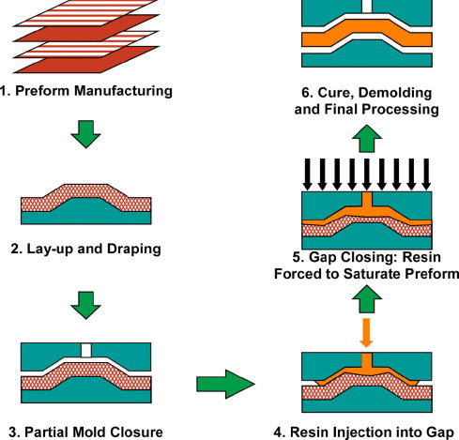

FIG 1: PROCESS OF RTM

**1.Mold design:** The mold is designed to the desired shape and size of the final part, considering factors such as material thickness and draft angles.

**2.Fabrication of the mold:** The mold is fabricated using materials such as fiberglass, carbon fiber, or aluminum.

**3.Preparation of the reinforcement material:** The reinforcement material, such as fiberglass or carbon fiber, is cut to size and prepared for use in the mold.

**4.Placement of the reinforcement material:** The reinforcement material is placed in the mold cavity, taking care to ensure proper alignment and positioning.

**5.Vacuum and resin injection:** A vacuum is applied to the mold cavity to remove any air or excess resin. The resin is then injected into the mold cavity under pressure, filling the voids in the reinforcement material.

**6.Curing:** The part is allowed to cure, typically at room temperature or in an oven, depending on the resin system being used.

**7.Demolding and finishing:** The part is demolded from the mold and any excess material is trimmed or sanded to achieve the desired shape and finish.

Overall, the RTM process is a cost-effective way to produce high-quality composite parts with excellent mechanical properties.

**2.2 COMPARING WITH OTHER MANUFACTURING METHODS**

Resin transfer molding (RTM) is a composite manufacturing method that has some similarities and differences with other manufacturing methods. Here are some comparisons between RTM and other manufacturing methods:

**1.Comparison with Open Molding:**

Open molding is a traditional method of composite manufacturing, where a mixture of resin and reinforcement material is poured or sprayed onto an open mold. Compared to RTM, open molding is less precise, and it has a higher tendency to create air pockets in the final product. In contrast, RTM produces parts with higher precision and lower porosity due to the controlled injection of resin into the mold.

**2.Comparison with Injection Molding:**

Injection molding is a manufacturing method used to produce plastic parts in high volumes. It involves melting plastic pellets and injecting them into a mold under high pressure. Compared to RTM, injection molding has a shorter cycle time, higher production rates, and the ability to produce complex geometries. However, it is limited to thermoplastics and cannot be used to manufacture composite parts

**3.Comparison with Compression Molding:**

Compression molding is a manufacturing method that involves placing a preform of reinforcement material in a mold and compressing it under high pressure and temperature. Compared to RTM, compression molding has a higher potential for producing large, thick parts, but it has a lower precision and longer cycle time.

**4.Comparison with Filament Winding:**

Filament winding is a manufacturing method that involves winding a fiber reinforcement around a rotating mandrel and impregnating it with resin. Compared to RTM, filament winding is suitable for producing hollow cylindrical parts with high strength-to-weight ratios. However, it has a higher cost and longer cycle time due to the need for a winding machine and mandrel.

**CHAPTER 3**

**MATERIALS USED IN RTM**

Resin Transfer Molding (RTM) is a manufacturing process that involves the injection of liquid resin into a mold cavity containing reinforcing fibers. The materials used in the RTM process can vary depending on the specific application, but typically include:

* RESIN (EPOXY RESIN LY556)
* HARDENER(HY951).
* REINFORCING FIBERS.
* MOLD.
* VACUUM PUMP.
* CURING AGENT.
* HOSE TUBE.
* PRESSURE REGULATOR.

**3.1. RESIN (EPOXY RESIN LY556)**

Resin is a liquid or semi-solid material that is used in a wide range of applications, including the manufacture of composite materials, adhesives, coatings, and paints. Resins are typically made from natural or synthetic materials that can be molded or shaped into a desired form. Epoxy resin is a commonly used type of resin in the manufacture of composite materials due to its excellent mechanical properties and ability to bond with reinforcing fibers. The most used resin in the RTM process is epoxy resin, such as LY556 Resin[4]. Other types of resin, such as polyester and vinyl ester, may also be used depending on the application. The curing process is usually controlled by adjusting the temperature and pressure during the injection and curing phases of the manufacturing process.LY556 Resin is also known for its excellent chemical resistance, which makes it ideal for use in harsh chemical environments. It is resistant to a wide range of chemicals, including acids, alkalis, solvents, and fuels[5]. Overall, LY556 Resin is a high-performance epoxy resin that is widely used in the manufacture of composite materials due to its excellent mechanical properties, chemical resistance, and ability to bond with reinforcing fibers.



FIG 2: LY556 RESIN

**HARDNER(HY951)**

HY951 Hardener is a liquid curing agent that is used to cure epoxy resins, such as LY556 Resin, in the manufacture of composite materials. It is a polyamide-based hardener that is designed to react with epoxy resins at room temperature or slightly elevated temperatures. HY951 Hardener provides a good balance of curing speed, mechanical properties, and toughness, making it suitable for a wide range of applications. It is known for its ability to provide excellent adhesion and bond strength between the epoxy resin and reinforcing fibers, resulting in strong and durable composite materials[6]. HY951 Hardener is often used in Resin Transfer Molding (RTM) processes, where the resin and hardener are mixed together and then injected into a mold cavity containing reinforcing fibers. The mixture then cures to form a rigid composite part. HY951 Hardener is also known for its excellent chemical resistance, which makes it ideal for use in harsh chemical environments. It is resistant to a wide range of chemicals, including acids, alkalis, solvents, and fuels. Overall, HY951 Hardener is a high-performance curing agent that is widely used in the manufacture of composite materials due to its excellent curing properties, adhesion, and chemical resistance.

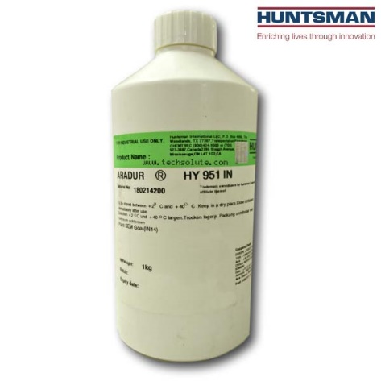

FIG 3: HY951 HARDENER

**REINFORCING FIBERS**

Reinforcing fibers are a key component in the manufacturing of composite materials. These fibers are typically made from materials such as carbon, glass, or aramid, and are used to provide strength and stiffness to the composite material. Carbon fibers are often used in high-performance applications where strength and stiffness are critical, such as in aerospace and automotive industries. Glass fibers, on the other hand, are more commonly used in applications where cost is a concern, such as in the construction industry. Aramid fibers, such as Kevlar, are known for their exceptional strength and are commonly used in ballistic and protective applications. The reinforcing fibers used in the RTM process are typically made from carbon fiber, glass fiber, or aramid fiber. These fibers are used to provide the composite material with its strength and stiffness. Glass fibers used in this experiment

Glass fibers, also known as fiberglass, are made from fine strands of molten glass. They are relatively inexpensive, have good strength-to-weight ratio, and provide excellent electrical insulation properties[7]. Glass fiber composites find applications in construction, marine, automotive, and consumer goods industries. However, it is important to note that glass fibers have lower tensile strength and stiffness compared to carbon fibers and other advanced reinforcement fibers. Additionally, they can be brittle and susceptible to breakage under extreme loads or impact. Therefore, the selection of reinforcement fibers should consider the specific requirements and performance characteristics of the intended application.

**Strength and Stiffness**: Glass fibers have good tensile strength and stiffness, providing structural integrity and load-bearing capability to composite materials. They enhance the overall strength of the composite and contribute to its ability to withstand external forces and loads.

**Cost-Effectiveness**: Glass fibers are relatively inexpensive compared to other reinforcement fibers, such as carbon fibers. This makes them an attractive option for applications where cost considerations are important, such as construction and consumer goods.

**Lightweight**: While not as lightweight as carbon fibers, glass fibers still offer a favorable strength-to-weight ratio. They can reduce the weight of composite components compared to traditional materials like metals, resulting in improved fuel efficiency in transportation applications and easier handling in various industries.

**Electrical Insulation**: Glass fibers have excellent electrical insulation properties. They do not conduct electricity, making them suitable for applications where electrical isolation is required, such as in electrical enclosures, printed circuit boards, and insulating materials.

**Corrosion Resistance**: Glass fibers are highly resistant to corrosion, making them suitable for applications where exposure to harsh environments or chemicals is a concern. They are commonly used in marine applications, chemical processing equipment, and infrastructure exposed to corrosive elements.

**Thermal Insulation**: Glass fibers provide good thermal insulation properties, reducing heat transfer through the composite material. This makes them valuable in applications that require temperature control, such as thermal insulation blankets, HVAC systems, and aerospace components.



FIG 4: GLASS REINFORMENT FIBER

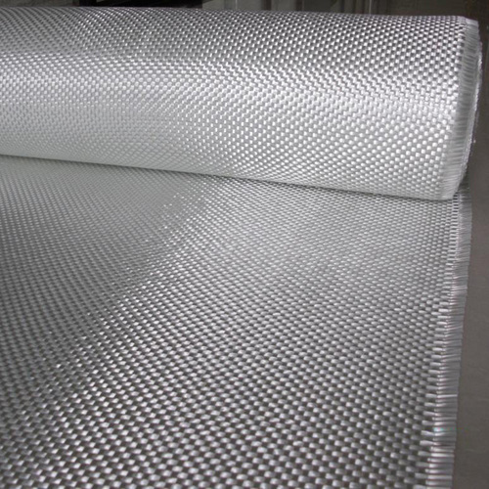

FIG 5 :GLASS FIBER ROLL

**MOULD**

A mold is a hollow container or cavity that is used to give shape to a material that is poured or injected into it. In the manufacturing of composite materials, molds are used to shape and form the composite material into a desired shape or size. Molds can be made from a variety of materials including metal, wood, fiberglass, and composites. The material used to create the mold will depend on factors such as the size and shape of the final product, the complexity of the mold, and the material being used to create the composite. Molds can be either open or closed, depending on the specific application. Open molds are typically used for simpler shapes and are left open to the atmosphere. Closed molds, on the other hand, are used for more complex shapes and are sealed to prevent the escape of the resin during the curing process[8]. The mold used in the RTM process is typically made from metal or composite materials, such as carbon fiber or fiberglass. The mold is designed to have a cavity that is the shape of the desired final part.

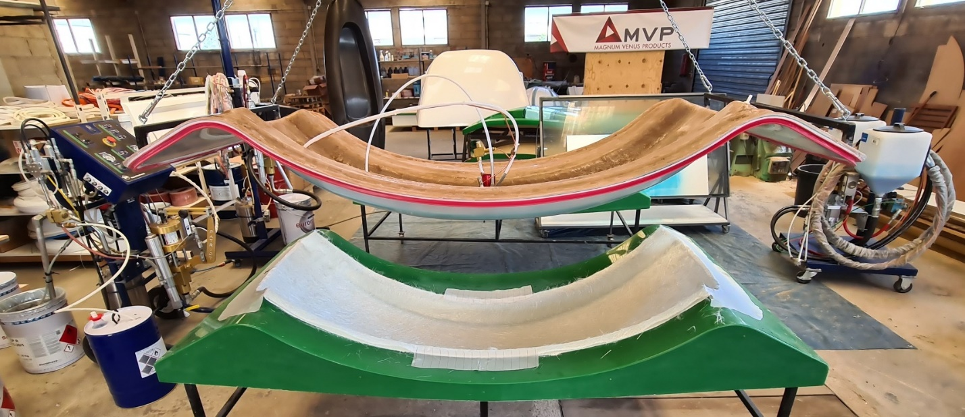

FIG 6: MOLD FOR RTM

**CURING AGENT**

A curing agent, also known as a hardener, is a chemical compound that is added to a resin system to promote and control the curing process. When mixed with the resin, the curing agent initiates a chemical reaction that causes the resin to harden and form a rigid structure. A curing agent, such as HY951 Hardener, is added to the resin to initiate the chemical reaction that causes the resin to harden and cure.



FIG 7: HY951 HARDENER

**HOSE TUBE**

The hoses used for pumping the resin and hardener should have a smooth interior surface to prevent any resin from sticking to the walls of the hose and potentially causing clogs or blockages. It is also important to select hoses and tubes with appropriate diameters to allow for the desired flow rate of resin and hardener. In addition, it is important to ensure that the hoses and tubes are properly connected and sealed to prevent any leaks or air ingress during the resin transfer process. Any leaks or air ingress can negatively impact the quality of the final product and can lead to increased waste and rework. Therefore, it is recommended to use high-quality hoses and tubes and to regularly inspect and maintain them to ensure their integrity.

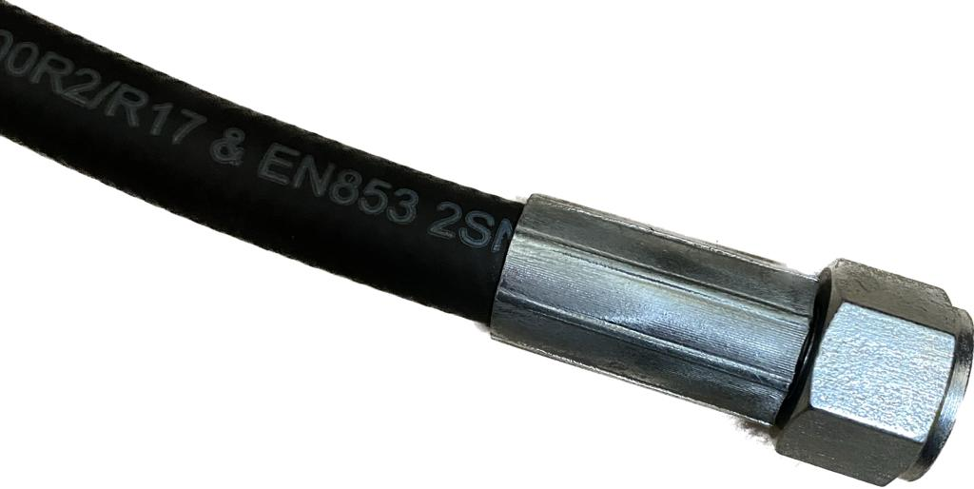

FIG 8: HOSE

**PRESSURE REGULATOR**

In resin transfer molding (RTM), a pressure regulator can be used to maintain a consistent pressure during the injection of resin into the mold. The pressure regulator helps to ensure that the resin is injected at a constant rate and pressure, which can help to produce a consistent and high-quality final product. The pressure regulator is typically installed in the resin line between the resin container and the mold. The regulator is set to the desired pressure level and is used to control the flow rate of the resin into the mold.

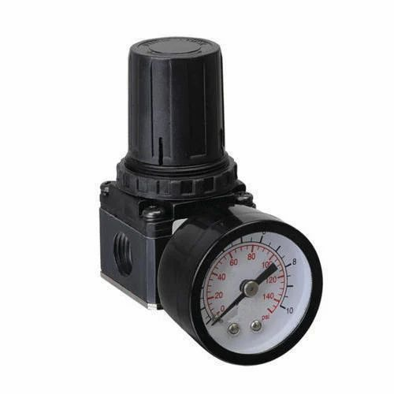

FIG 9: PRESSURE REGULATOR

**VACCUM PUMP**

In Resin Transfer Moulding (RTM), a vacuum pump is commonly used to assist in the resin infusion process. The vacuum pump helps create a pressure differential within the mold cavity, which facilitates the flow of resin through the preform and ensures thorough impregnation of the reinforcement fibers[9].



FIG 10: VACCUM PUMP

**SPECIFICATIONS OF VACCUM PUMP**

TABLE 1: PUMP SPECIFICATIONS

|  |  |
| --- | --- |
| **PARAMETERS** | **VALUE** |
| NOMINAL CAPACITY | 17 m3/hr |
| ULTIMATE PRESSURE | 0.5 mbar |
| OPERATING VOLTAGE | 415 V 50hz 3 phase |
| MOTOR POWER | 0.55 KW |
| MOTOR SPEED | 1400 RPM |
| OIL CAPACITY | 1 LITER |
| BRAND | Toshniwal |
| MODEL NUMBER | TMS 15 |

**CHAPTER 4**

**EXPERIMENTAL PROCEDURE**

**4.1 MOULD PREPARATION**

There are 7 major steps to prepare the mold before injecting the resin mixture.

1. **Clean the mould**: The mold should be free of any dirt or contaminants that could mess with the resin flow or the adhesion of the part. Clean the mold with a suitable solvent or cleaning agent and be mold should completely dry before proceeding.
2. **Apply release agent**: Apply a release agent to the mold surface to prevent the part from sticking to the mold during the RTM process. Make sure to apply the release agent evenly for better result**.**
3. **Install the injection ports:** The injection ports are the channels through which the liquid resin will flow into the mold. Install the injection ports at the important locations on the mold surface, considering the resin flow and the part geometry.
4. **Install the fiber reinforcement**: The fiber reinforcement should be pre-placed in the mold cavity before the RTM process begins. Make sure the fibers are arranged in the desired orientation and that they are properly positioned to achieve the desired mechanical properties of the part.
5. **Close the mold:** Once all the components are in place, close the mold and secure it with clamps or other suitable means. Make sure the mold is completely sealed to prevent any resin leakage.
6. **Inject the resin:** Inject the liquid resin into the mold cavity through the injection ports, by using a suitable pump. Monitor the resin flow and adjust the injection pressure and flow rate as needed to ensure a complete and uniform resin transfer.
7. **Cure the part**: After the resin transferring is complete, cure the part for one day. This process normally done in room temperature conditions

**4.2 RESIN MIXING AND INJECTION**

The resin is firstly prepared with a suitable hardener in correct proportions. In this experiment we have used in the ratio of 10:1, That is ten parts of resin LY556 and one part of hardener HY951. A stirrer or an electrical mixture is used to mix the compounds thoroughly. Air bubbles are avoided while mixing the compounds. This mixture is injected by using a pump into the cavity of molds. A constant flow rate and pressure is maintained for obtaining good finish of a part.

After injection the part is allowed to cure for required time. The curing rate should be at a constant rate for a good quality product. Accurate measurement and thorough mixing of the resin components are essential for achieving a homogenous and well-cured composite[10]. The mixing process can be performed manually or by using specialized equipment such as a mechanical stirrer or a mixing machine. It is crucial to follow the resin guidelines regarding mixing time, mixing speed, and any specific instructions for the resin system. The resin is injected into the mold cavity through designated inlet points or injection ports. The flow front is carefully controlled to ensure even distribution of resin throughout the mold and preform, resulting in uniform reinforcement impregnation.

**4.3 CURING PROCESS**

In Resin Transfer Moulding (RTM), the curing process is a critical step that solidifies the resin and impregnates the reinforcement fibers, resulting in a fully cured composite part with the desired mechanical properties. The curing process involves the activation of the resin system, allowing it to undergo a chemical reaction and transition from a liquid to a solid state.

A constant flow rate and pressure is maintained for obtaining good finish of a part. After injection the part is allowed to cure for required time. The curing time changes with respect to shape, geometry, and thickness[11]. The curing rate should be at a constant rate for a good quality product. In this experiment one day is used to cure the product. Room temperature is ideal for curing the part.

**4.4 POST-CURING AND FINISHING**

After the part is fully cured, it is removed carefully from the mold. The part is thoroughly cleaned with a cloth and trimmed off the excess pieces with a scissor or any sharp object. Sanding can be done with a fine sandpaper to get smooth surface finish. The part is fully completed. After the initial molding or curing process, some composite materials may undergo post-curing to further enhance their properties. Post-curing involves subjecting the composite part to elevated temperatures for a specific duration, often in a controlled oven or autoclave environment. This additional heat treatment promotes further crosslinking and consolidation of the resin matrix, resulting in increased strength, stiffness, and dimensional stability of the composite[7].

Post-curing is particularly important for thermosetting resins, such as epoxy or polyester, which continue to cure and develop their properties over time. It helps ensure complete curing of the resin, reducing the potential for residual stresses, improving chemical resistance, and achieving the desired mechanical performance of the composite. Finishing: Finishing processes are employed to improve the appearance, surface quality, and functionality of composite components. Here are some common finishing techniques

**Trimming**: Trimming involves removing excess material from the edges or flash lines of the composite part to achieve the desired shape and dimensions. This is typically done using cutting tools or CNC machining.

**Sanding and Grinding**: Sanding and grinding are used to smooth the surface of the composite component, removing imperfections, such as uneven surfaces, tool marks, or excess resin. Various grits of sandpaper or abrasive wheels are employed to achieve the desired level of surface smoothness.

**Painting and Coating**: Painting or coating the composite surface can enhance its appearance, provide color, and protect against environmental factors, such as UV radiation or chemical exposure. Paints, varnishes, or protective coatings specifically formulated for composites are applied using conventional spray or brush methods.

**Polishing**: Polishing is performed to achieve a glossy, smooth surface finish. It involves using polishing compounds, abrasives, or buffing wheels to remove fine scratches or imperfections and create a reflective finish.

These finishing processes are carried out with precision and care to meet the desired aesthetics, functional requirements, and performance specifications of the composite component.

Overall, post-curing and finishing are critical steps in the manufacturing process of composite components. They ensure the attainment of desired mechanical properties, dimensional accuracy, and visual appeal, contributing to the overall quality and performance of the final product.

**CHAPTER 5**

**CONCLUSION**

In conclusion, resin transfer moulding, often known as RTM, is a manufacturing method that can create complicated, high-quality products with predictable attributes and dimensions. RTM may be automated for more efficiency and is excellent for creating large parts. Despite these drawbacks, RTM is a useful technology that has been used in a variety of sectors, including the aerospace, automotive, and marine industries. Due to its special qualities, it is a practical choice for creating composite parts that adhere to exacting standards for performance, strength, and durability. Overall, a variety of parameters, such as the desired part attributes, production volume, and available resources, determine whether RTM is appropriate for a given application[12]. To decide whether RTM is the best approach for a particular project, these elements must be carefully considered. In conclusion, resin transfer moulding (RTM) is a valuable manufacturing process used in the production of composite materials. The resin content in RTM plays a crucial role in determining the final properties of the composite parts. Low resin content can lead to poor fibre impregnation and compromised mechanical properties, while high resin content can cause dimensional instability and potential part distortion. Finding the optimal resin content is essential for achieving the desired mechanical properties, such as strength, stiffness, and durability. The right balance ensures proper fibre wetting, minimal void content, and good consolidation, resulting in high-performance composite materials. Careful consideration, testing, and adherence to specific application requirements are necessary when determining the appropriate resin content for successful resin transfer moulding.

**6 REFERENCES**

[1] M. Y. Lin, M. J. Murphy, and H. T. Hahn, “Resin transfer molding process optimization.” [Online]. Available: www.elsevier.com/locate/compositesa

[2] F. R. Phelan, “Simulation of the Injection Process in Resin Transfer.”

[3] E. Tempelman, H. Shercliff, and B. N. van Eyben, “Resin Transfer Molding,” in Manufacturing and Design, Elsevier, 2014, pp. 171–186. doi: 10.1016/B978-0-08-099922-7.00010-X.

[4] R. Seifi and M. Hojjati, “Heat of reaction, cure kinetics, and viscosity of araldite LY-556 resin,” J Compos Mater, vol. 39, no. 11, pp. 1027–1039, 2005, doi: 10.1177/0021998305048738.

[5] “Araldite ® LY556 / Hardener XB3473 Advanced Materials Araldite ® LY 556* / Hardener XB 3473* HOT CURING EPOXY SYSTEM.”

[6] Huntsman, “Araldite ® Casting System Araldite ® DBF Resin 100 pbw Aradur ® HY 951 Hardener 10 pbw,” 2005. [Online]. Available: http://www.electrical-insulation-materials.com

[7] T. P. Sathishkumar, S. Satheeshkumar, and J. Naveen, “Glass fiber-reinforced polymer composites - A review,” Journal of Reinforced Plastics and Composites, vol. 33, no. 13. SAGE Publications Ltd, pp. 1258–1275, 2014. doi: 10.1177/0731684414530790.

[8] W. IL Lee, “A Study on the Mold Filling Process in Resin Transfer.”

[9] “PV-TOL-1_3nBCfPh (1)”.

[10] C. Zhong, “Simplified Mold Filling Simulation in Resin Transfer Molding,” J Compos Mater, vol. 26, no. 17, pp. 2606–2630, 1992, doi: 10.1177/002199839202601708.

[11] L. Sun, S. S. Pang, A. M. Sterling, I. I. Negulescu, and M. A. Stubblefield, “Thermal analysis of curing process of epoxy prepreg,” J Appl Polym Sci, vol. 83, no. 5, pp. 1074–1083, Jan. 2002, doi: 10.1002/app.10053.

[12] D. Rouison, M. Sain, and M. Couturier, “Resin transfer molding of natural fiber reinforced composites: Cure simulation,” Compos Sci Technol, vol. 64, no. 5, pp. 629–644, 2004, doi: 10.1016/j.compscitech.2003.06.001.